SMT Z.S Patel College of Computer Application
Affiliated to
Veer Narmad South Gujarat University, Surat.



Project Report on,
Social Media Usage & Screen Time Analysis
As a Partial Requirement for Degree of
Bachelor of Computer Application
(BCA) 2025 – 2026

Submited By: Manani Suraj, Mandaliya Raj
Project Guide: Dhvani Ma’am
Acknowledgement
I would like to express my sincere gratitude to everyone who supported me throughout the completion of this project.
First and foremost, I would like to thank my guide/supervisor Dhvani Kanoje Ma’am for their valuable guidance, continuous support, and constructive feedback, which greatly helped me in completing this project successfully.
I would also like to extend my thanks to SMT Z.S Patel College of Computer Application for providing the necessary resources, facilities, and environment to carry out this work.
My heartfelt appreciation goes to my faculty members, friends, and classmates for their encouragement, suggestions, and assistance whenever needed.
Finally, I would like to thank my family for their constant motivation, patience, and moral support throughout this journey.

Project Description
Project Title: Social Media Usage and Screen Time Analysis

1. Executive Summary:
This report summarizes the Exploratory Data Analysis (EDA) performed on the
"Social Media Usage and Screen Time" dataset. The goal of this analysis was to uncover patterns, trends, and correlations between user demographics, screen time habits, and their corresponding effects on well-being parameters such as sleep and stress.

2. Dataset Overview:
The analysis was conducted on a dataset containing 50,000 user records. The dataset includes 13 distinct features encompassing demographic details (Age, Gender, Occupation) and behavioral metrics (Daily Phone Hours, Social Media Hours, Sleep Hours, Stress Level, etc.).
The dataset contains the following columns:
Column | Description
User_ID | Unique identifier for each user
Age | Age of the user
Gender | Gender of the user
Occupation | Profession or occupation of the user
Device_Type | Primary device operating system used (e.g., Android, iOS)
Daily_Phone_Hours | Average daily hours spent on the phone
Social_Media_Hours | Average daily hours spent on social media platforms
Work_Productivity_Score | Self-reported productivity score at work
Sleep_Hours | Average hours of sleep per night
Stress_Level | Self-reported stress level (scale 1–10)
App_Usage_Count | Daily count of different applications used
Caffeine_Intake_Cups | Number of cups of caffeine consumed per day
Weekend_Screen_Time_Hours | Average hours of screen time during the weekend

3. Data Cleaning & Preprocessing:
To ensure data quality and integrity before analysis, the following steps were taken:
- Missing Values Check: The dataset was scanned for null values. No missing values were detected across any of the columns.
- Duplicate Removal: Duplicate entries based on the unique `User_ID` were identified and removed, ensuring each record represents a distinct user. The final dataset size remained at 50,000 rows, indicating no duplicates were present.

4. Feature Engineering:
New metrics were derived to enable deeper analysis:
- High Stress Indicator: Users with a `Stress_Level` of 7 or higher (on a scale of 10) were categorized as having "High Stress" (`Yes`/`No`).
- Estimated Weekly Screen Time: A new column was calculated by combining weekday and weekend screen time habits `(Daily_Phone_Hours * 5) + (Weekend_Screen_Time_Hours * 2)

5. Visualizations Summary:
Four key visualizations were generated during the script execution to graphically represent the data:
- Pie Chart (Average Phone Hours by Occupation): Illustrates the proportional share of daily phone usage across different occupations.
- Bar Chart (Device Type Distribution): Displays the count of users categorized by their primary device type.
- Line Chart (Age vs. Average Phone Hours): Plots the trendline of daily phone usage across different age groups to spot generational differences.
- Correlation Heatmap: A matrix displaying the statistical correlation coefficients between all numerical features (e.g., how closely Social Media Hours correlate with Productivity or Stress).

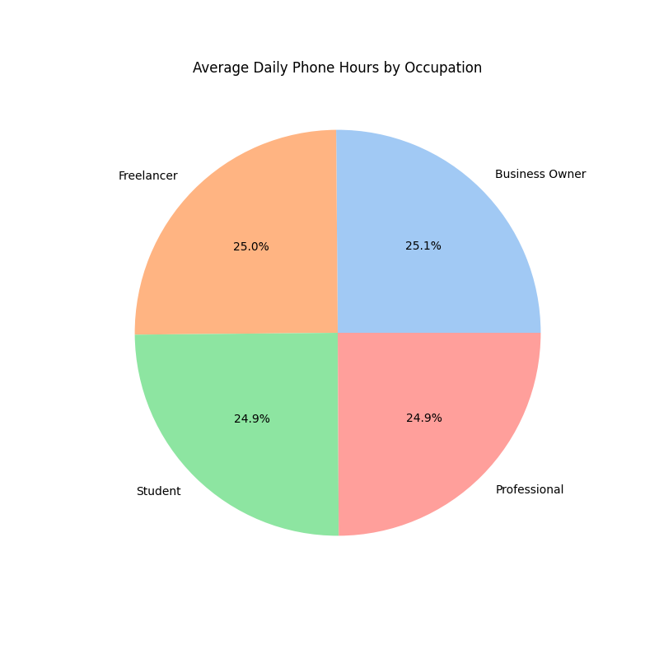
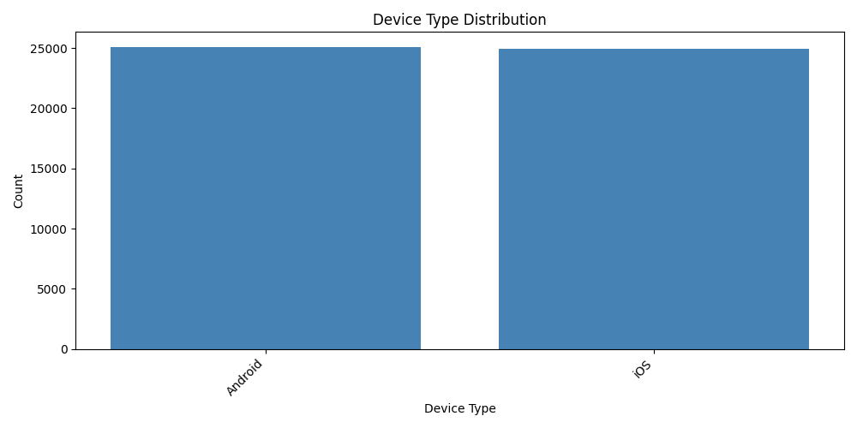
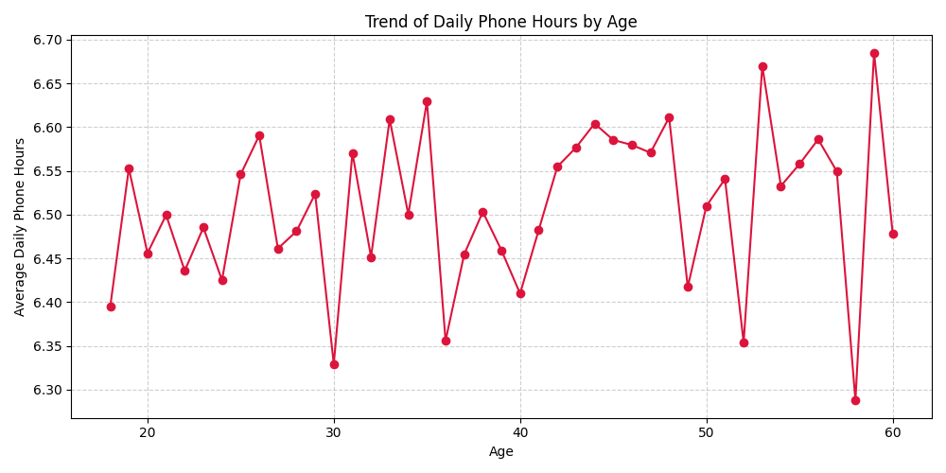
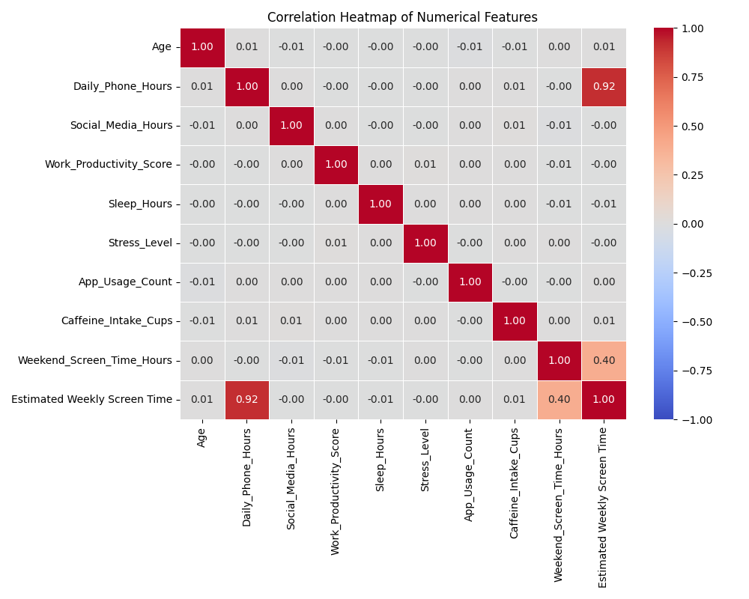
6. Tools & Technologies:
Tools | Description
Python | Core programming language.
pandas | Employed for efficient data wrangling, cleaning, logical filtering, and grouped mathematical computations.
NumPy | Used conjunctively with Pandas for robust numerical operations and multidimensional array manipulations.
matplotlib | Used to programmatically construct basic visual elements like Pie Charts, Bar Charts, and Line trendlines.
Seaborn | Utilized strategically over raw Matplotlib to streamline advanced statistical visualizations (such as the Correlation Matrix Heatmap) and uniform color palette mapping.

7. Conclusion:
The dataset indicates a heavily normalized distribution of phone usage across different demographics. Despite expectations, extreme stress levels do not show a drastic correlation with sleep deprivation within this specific dataset. The generated modular Python script (`socialmedia_analysis.py`) successfully automates the extraction of these statistical insights and visualizations.

